**Scansione Finale**

**metasploitable**

# TABLE OF CONTENTS

# Vulnerabilities by Host

• 192.168.50.101

# Vulnerabilities by Host

Questa è la scansione effettuata dopo aver risolto alcune criticità, infatti possiamo notare meno criticità.

|  |  |  |  |  |  |
| --- | --- | --- | --- | --- | --- |
| CRITICAL | | HIGH | MEDIUM | LOW | INFO |
| Vulnerabilities | |  |  |  | Total: 107 |
| **SEVERITY** | **CVSS V3.0** | **PLUGIN NAME** |  |  |  |

|  |
| --- |
| CRITICAL |

9.8 [134862](http://www.nessus.org/plugins/index.php?view=single&id=134862)  Apache Tomcat A JP Connector Request Injection (Ghostcat)

CRITICAL

9.8

[7](http://www.nessus.org/plugins/index.php?view=single&id=20007)

[2000](http://www.nessus.org/plugins/index.php?view=single&id=20007)

SSL

Version

2

and

3

Protocol

Detection

CRITICAL

10.0

[0](http://www.nessus.org/plugins/index.php?view=single&id=33850)

[3385](http://www.nessus.org/plugins/index.php?view=single&id=33850)

Unix

Operating

System

Unsupported

Version

Detection

|  |
| --- |
| CRITICAL |

10.0* [32314](http://www.nessus.org/plugins/index.php?view=single&id=32314)  Debian OpenSSH/OpenSSL Package Random Number Generator

Weakness

|  |  |  |  |  |
| --- | --- | --- | --- | --- |
|  | **192.168.1.36** | |  |  |
| 5 | 4 | 16 | 5 | 77 |

|  |
| --- |
| CRITICAL |

10.0* [32321](http://www.nessus.org/plugins/index.php?view=single&id=32321)  Debian OpenSSH/OpenSSL Package Random Number Generator

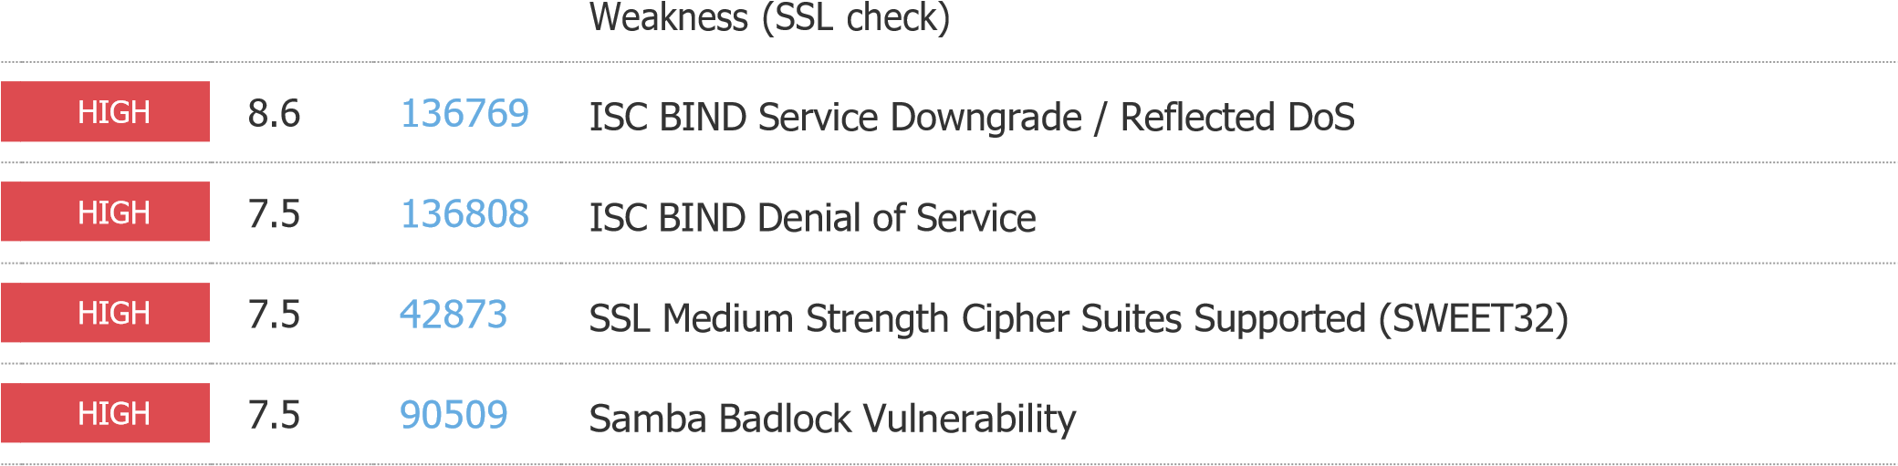

|  |
| --- |
| MEDIUM |

6.8 [78479](http://www.nessus.org/plugins/index.php?view=single&id=78479)  SSLv3 Padding Oracle On Downgraded Legacy Encryption Vulnerability

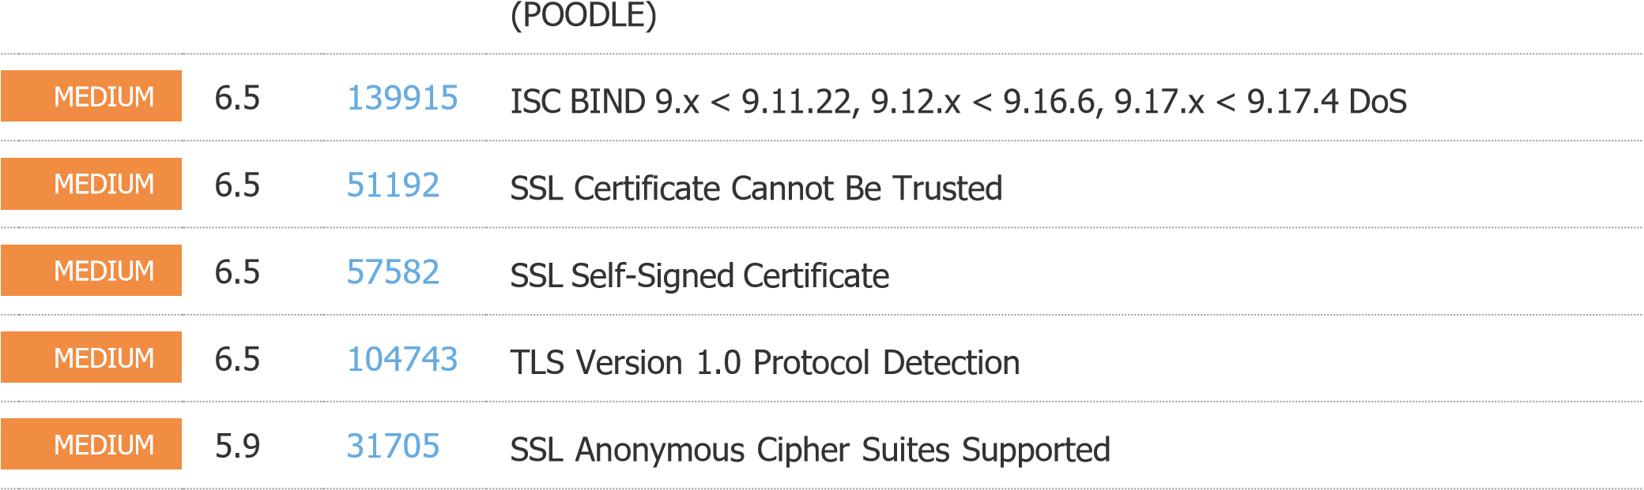

|  |
| --- |
| MEDIUM |

5.9 [89058](http://www.nessus.org/plugins/index.php?view=single&id=89058)  SSL DROWN Attack Vulnerability (Decrypting RSA with Obsolete and

Weakened eNcryption)

|  |
| --- |
| MEDIUM |

5.9 [65821](http://www.nessus.org/plugins/index.php?view=single&id=65821)  SSL RC4 Cipher Suites Supported (Bar Mitzvah)

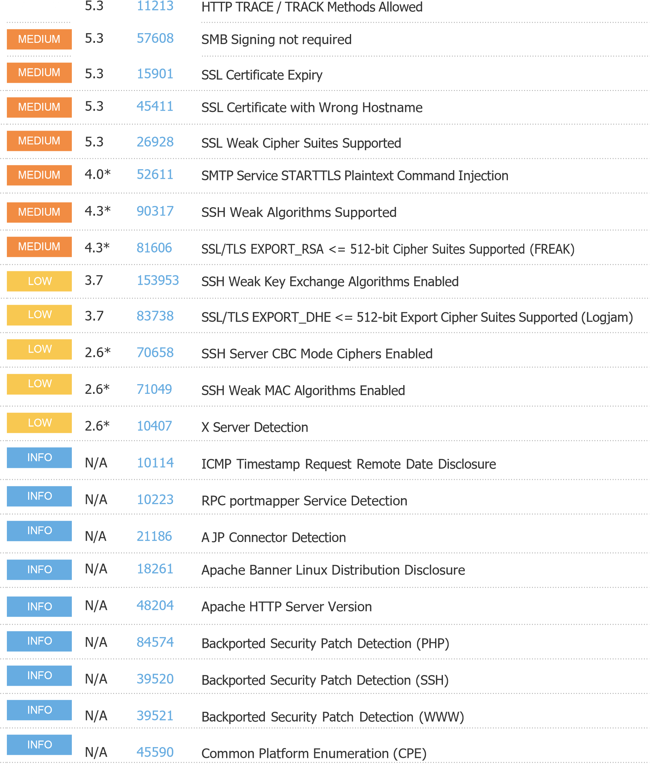

N/A [10028](http://www.nessus.org/plugins/index.php?view=single&id=10028)  DNS Server BIND version Directive Remote Version Detection

N/A

[1100](http://www.nessus.org/plugins/index.php?view=single&id=11002)

[2](http://www.nessus.org/plugins/index.php?view=single&id=11002)

DNS

Server

Detection

INFO

|  |
| --- |
| INFO |

N/A [72779](http://www.nessus.org/plugins/index.php?view=single&id=72779)  DNS Server Version Detection

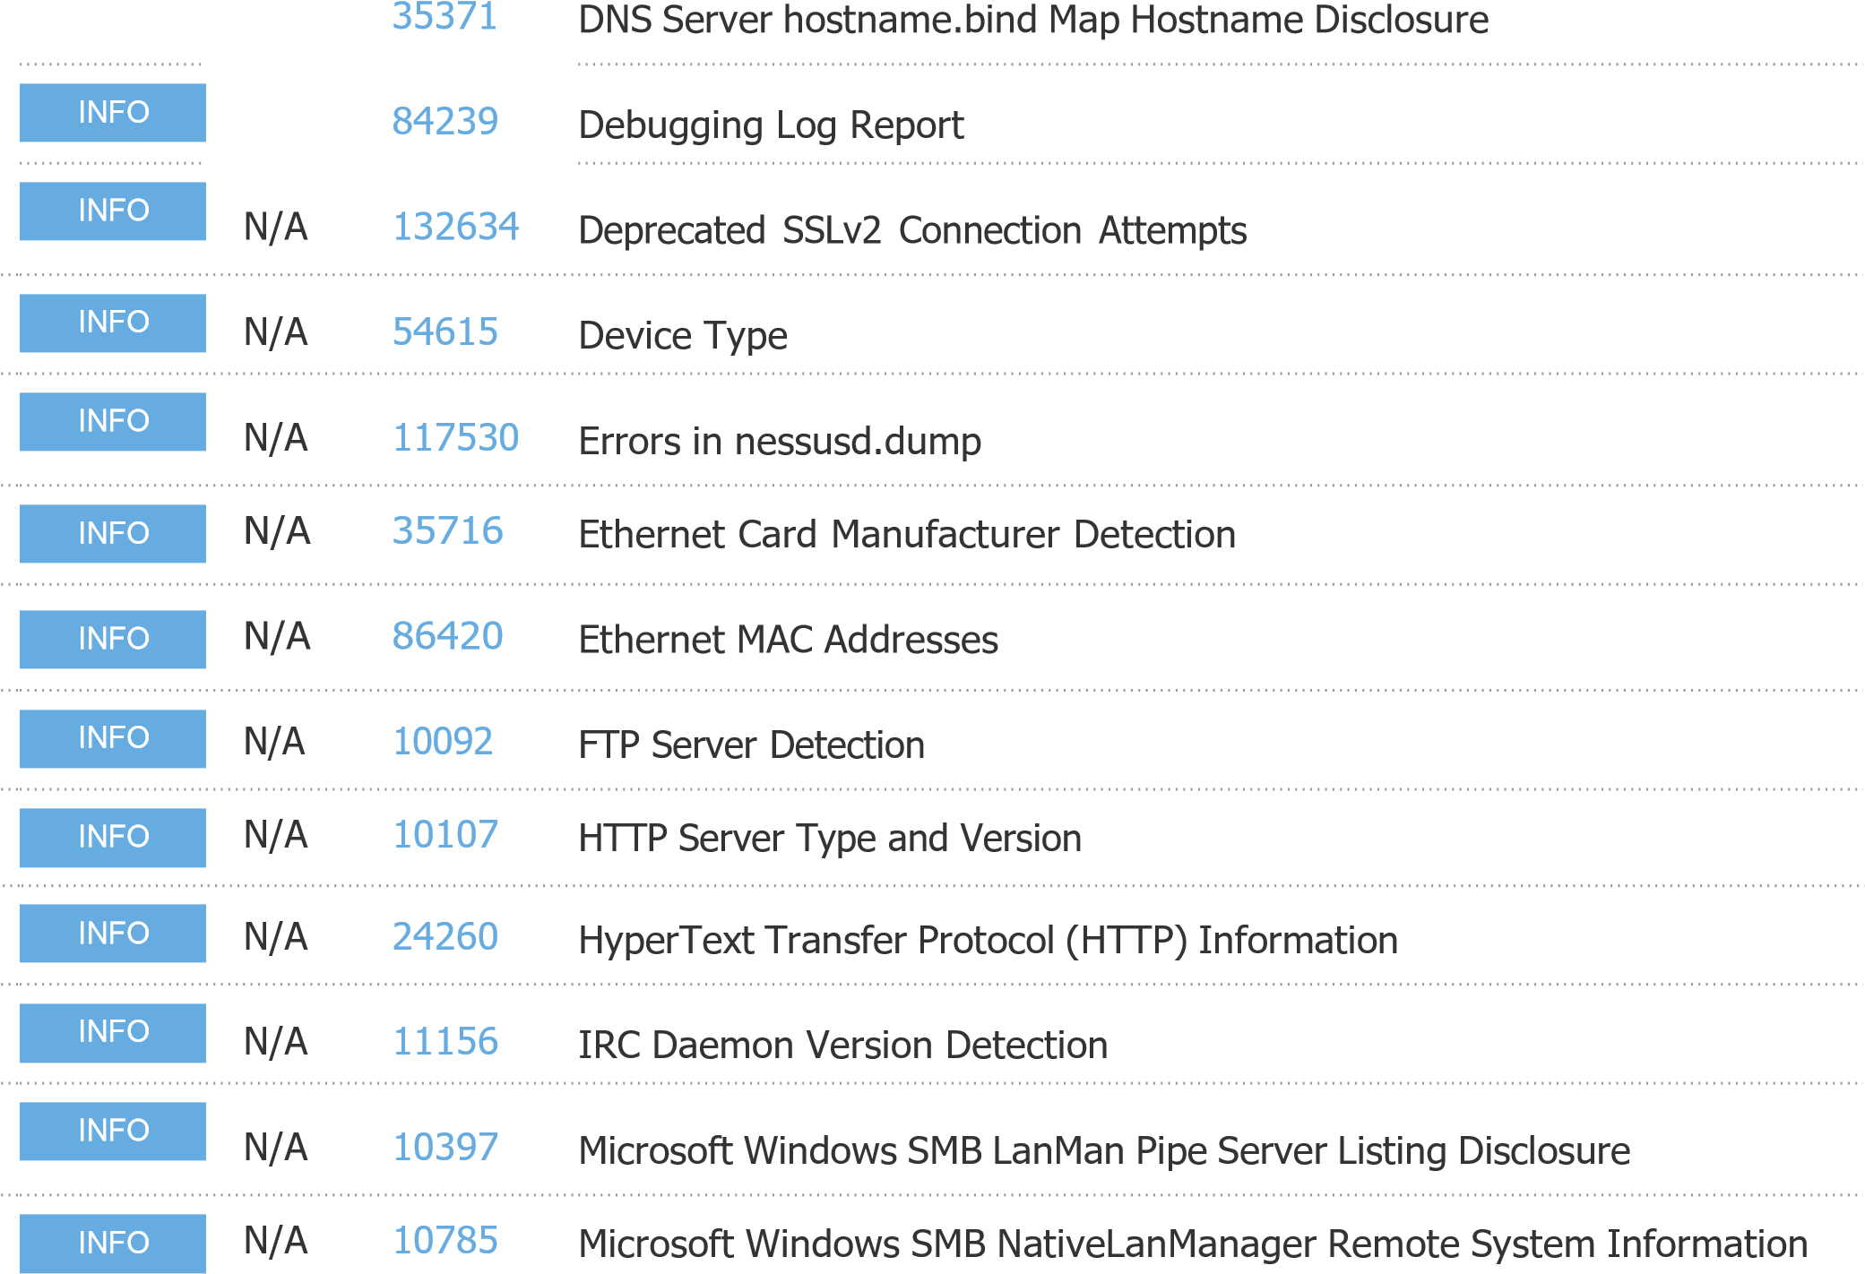

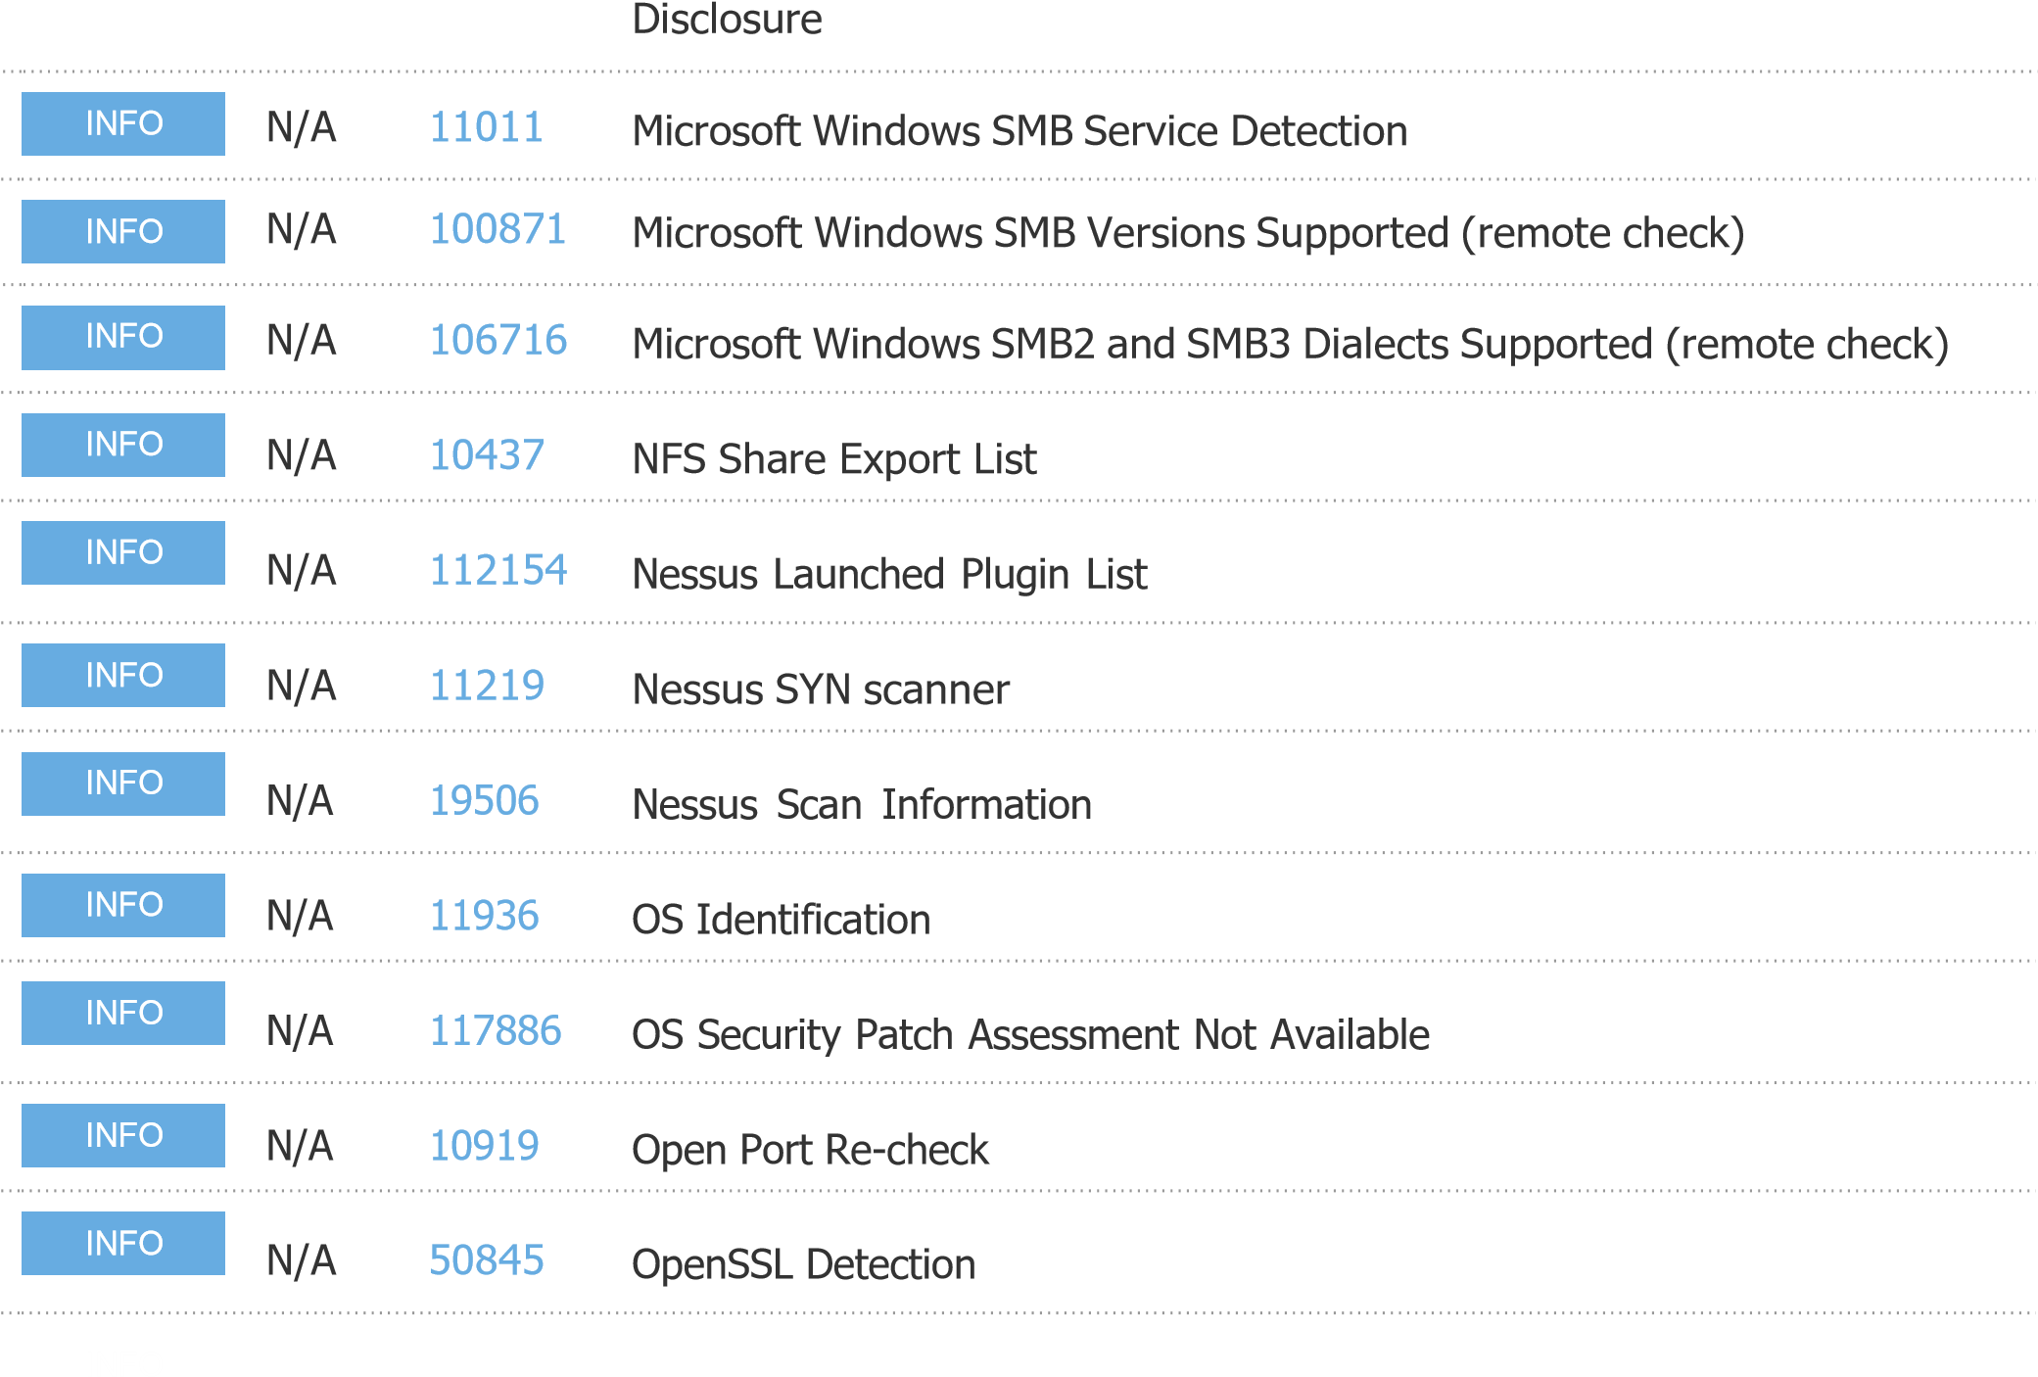

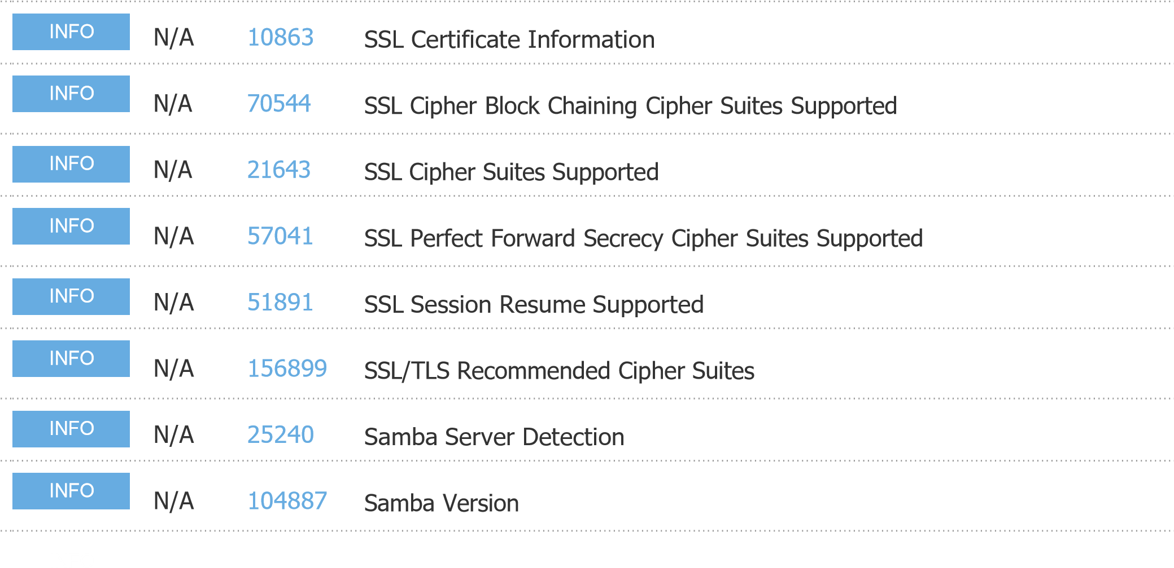

[4](http://www.nessus.org/plugins/index.php?view=single&id=66334)

[6633](http://www.nessus.org/plugins/index.php?view=single&id=66334)

Patch

Report

[0](http://www.nessus.org/plugins/index.php?view=single&id=10180)

[1018](http://www.nessus.org/plugins/index.php?view=single&id=10180)

Ping

the

remote

host

N/A

[4](http://www.nessus.org/plugins/index.php?view=single&id=118224)

[11822](http://www.nessus.org/plugins/index.php?view=single&id=118224)

PostgreSQL

STARTTLS

Support

N/A

[2602](http://www.nessus.org/plugins/index.php?view=single&id=26024)

[4](http://www.nessus.org/plugins/index.php?view=single&id=26024)

PostgreSQL

Server

Detection

N/A

[2222](http://www.nessus.org/plugins/index.php?view=single&id=22227)

[7](http://www.nessus.org/plugins/index.php?view=single&id=22227)

RMI

Registry

Detection

N/A

[1](http://www.nessus.org/plugins/index.php?view=single&id=11111)

[1111](http://www.nessus.org/plugins/index.php?view=single&id=11111)

RPC Services Enumeration

INFO

INFO

INFO

INFO

INFO

INFO

N/A

[5333](http://www.nessus.org/plugins/index.php?view=single&id=53335)

[5](http://www.nessus.org/plugins/index.php?view=single&id=53335)

RPC

portmapper

(

TCP

)

N/A

[1026](http://www.nessus.org/plugins/index.php?view=single&id=10263)

[3](http://www.nessus.org/plugins/index.php?view=single&id=10263)

SMTP

Server

Detection

N/A

[4208](http://www.nessus.org/plugins/index.php?view=single&id=42088)

[8](http://www.nessus.org/plugins/index.php?view=single&id=42088)

SMTP

Service

STARTTLS

Command

Support

INFO

INFO

INFO

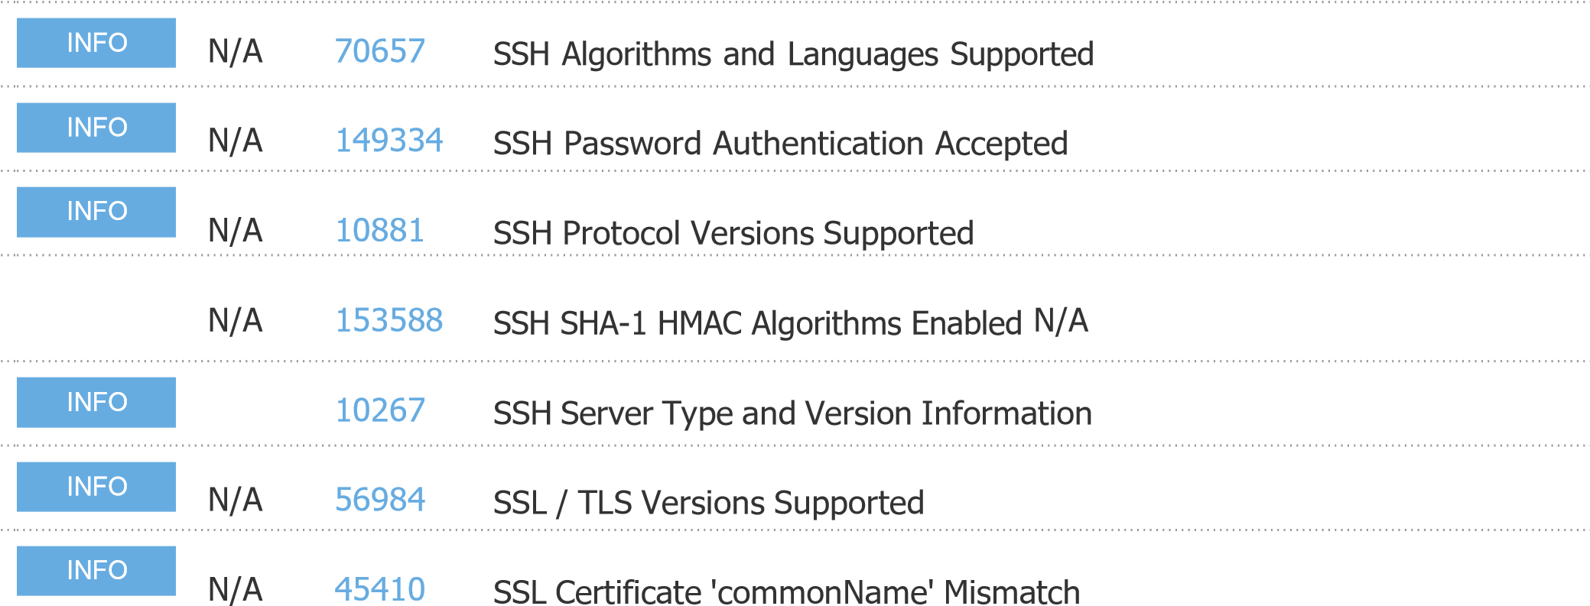

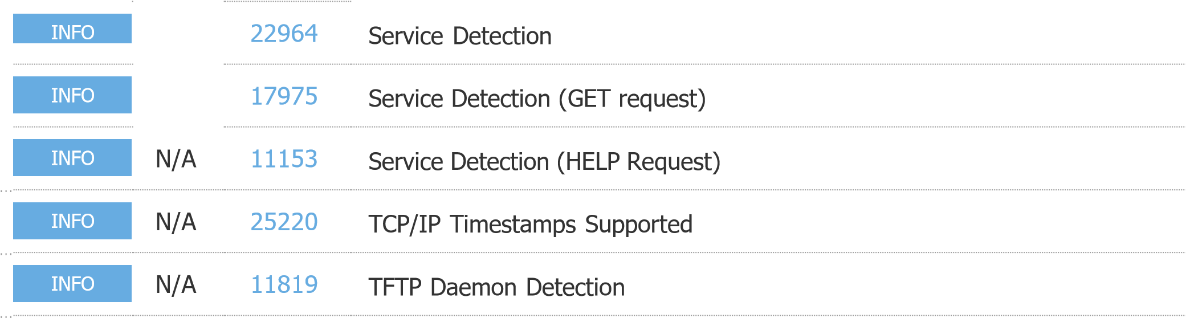

|  |
| --- |
| INFO |

N/A [110723](http://www.nessus.org/plugins/index.php?view=single&id=110723) Target Credential Status by Authentication Protocol - No Credentials

